1.Write a program to find the perfect number.

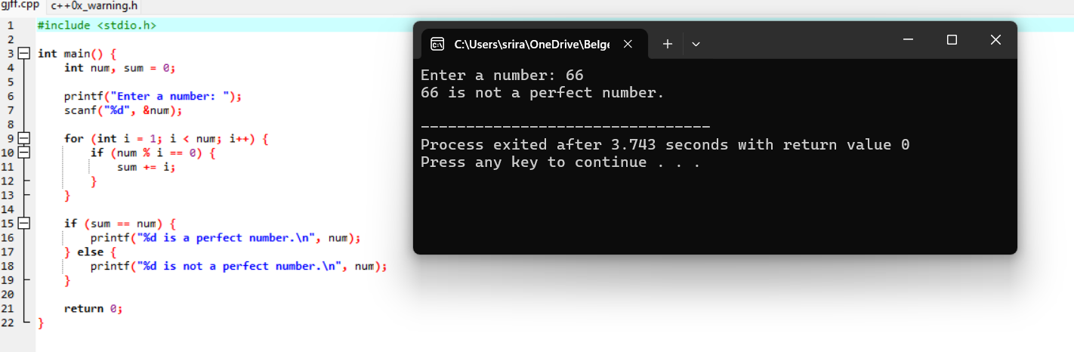

2.Write a program to perform travelling salesman problem using dynamic programming

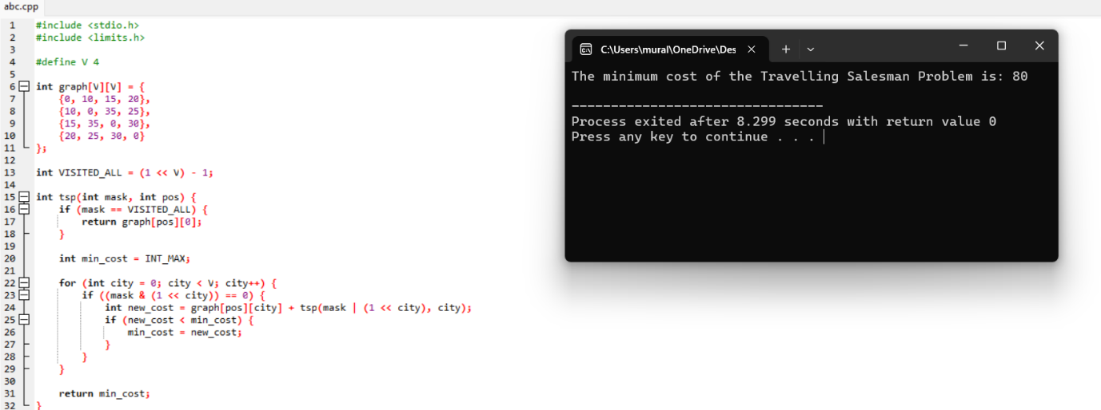

3.Write a program for the given pattern

If n=4

1

1 2

1 2 3

1 2 3 4

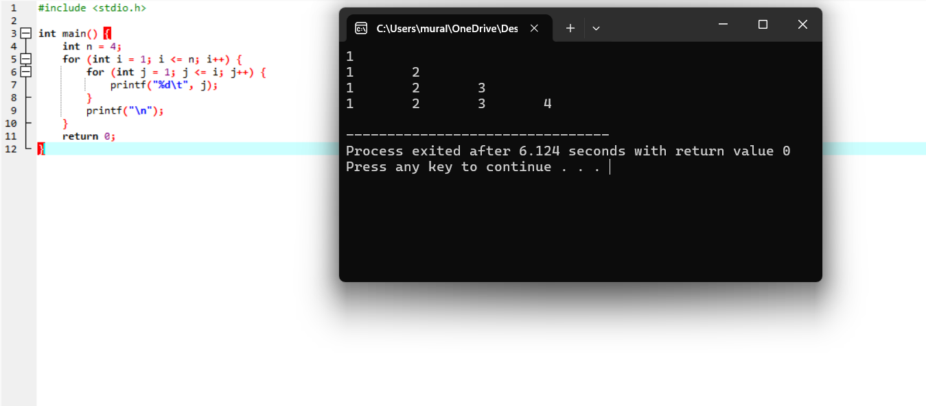

4.Write a program for pascal triangle.

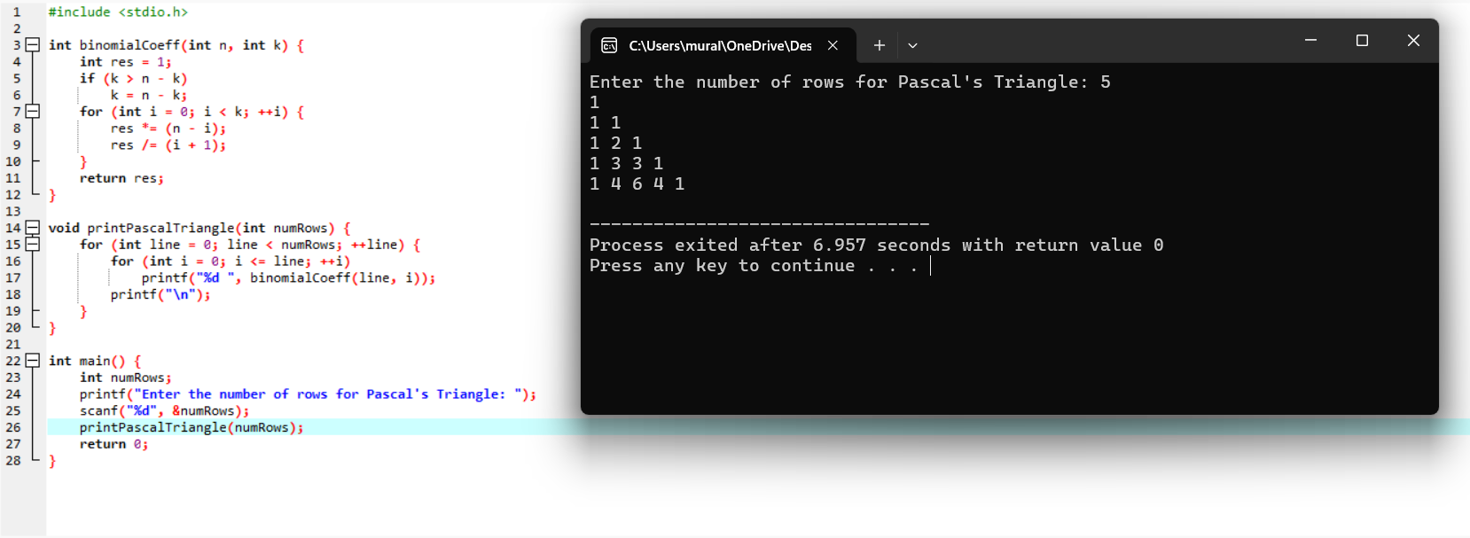

5.Write a program to find the sum of digits.

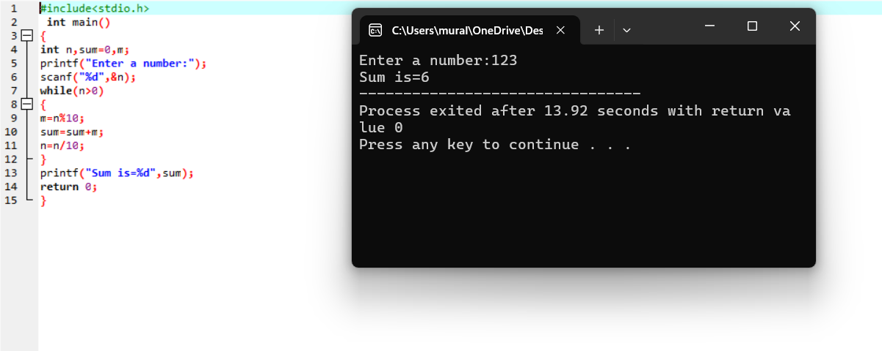

6.Write a program to print a minimum and maximum value sequency for all the numbers in a list.

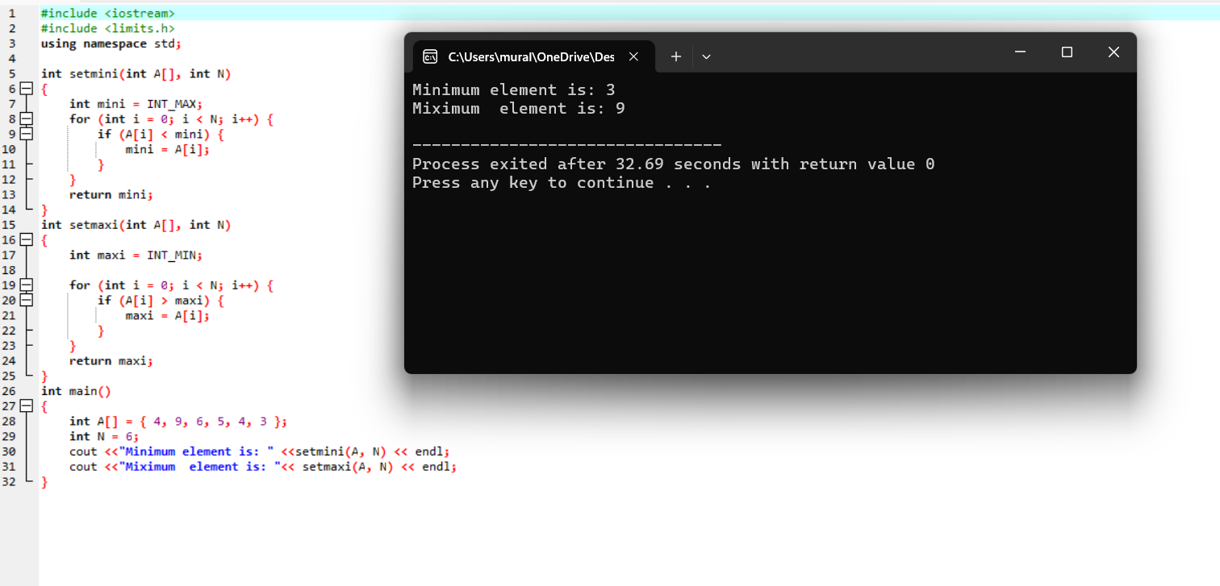

7. Write a program to inset a number in a list.

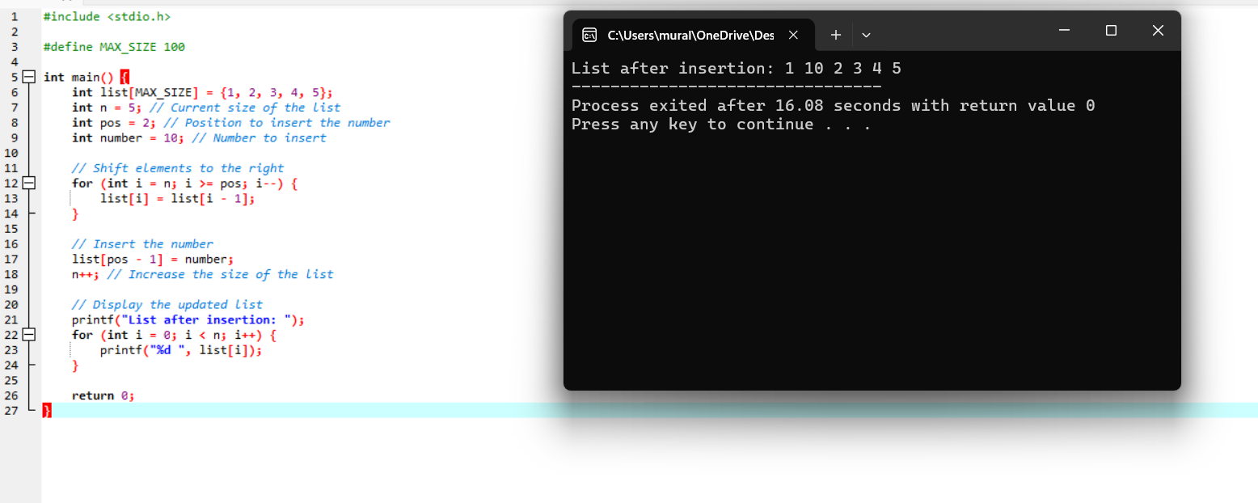

8. Write a program to generate the list of all factor for n value.

